Solar Charger Shield V2.2

1. Features:

* Output Disconnect
* Short circuit protection
* 3W Output Power when connecting battery
* Continuous Charge Current Up to 900mA
* Battery status indication ( Red : Charging , Green: Charged )
* Micro-USB Connector

1. Specification

* Battery input voltage: 3.0~4.5V
* USB input voltage: 4.75~5.25V
* Solar input voltage: 4.8~6V
* Maximum Output Power(with battery): 3W(600mA@5V)
* Ripple voltage: <100mV @ 500mA
* Dimensions: 68*53mm

1. Applications

* Wireless sensor unit
* Solar charge
* Tweet-a-volt-arduino

1. Caution

* The solar charger shield is designed to protect any potential short circuit. However care must be taken to avoid any such situations.
* The solar shield should not be operated at voltages greater than 5V

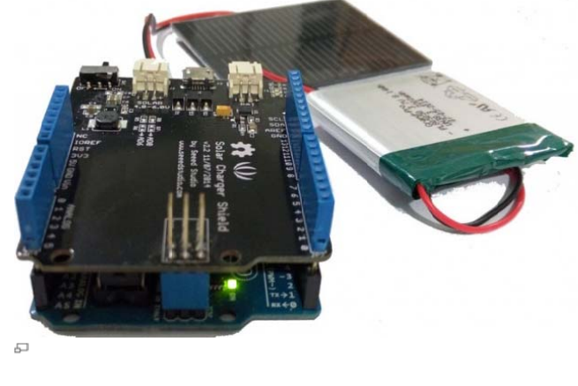

USB, DC & Solar Lipoly Charger

1. Specifications

* 3.7V/4.2V Lithium Ion or Lithium Polymer battery charger
* Charge with 5-6V DC, USB or 6V solar panel!
* Automatic charging current tracking for high efficiency use of any wattage solar panel
* Use any 6V solar panel
* Three color indicator LEDs - Power good, Charging and Done
* Low Battery Indicator (fixed at 3.1V) with LED output on (labeled CHRG)
* Set for 500mA max charge rate, can be adjusted from 50mA up to 1A by soldering in a resistor
* Will always draw the most current possible from a solar cell- up to the max charge rate!
* Smart load sharing automatically uses the input power when available, to keep battery from constantly charging/discharging
* Temperature monitoring of battery by soldering in a 10K NTC thermistor (http://adafru.it/372) (not included) - suggested for outdoor projects where the battery may get hot (50°C) or cold (0°C).

1. Installing the Capacitor

* This capacitor is necessary to stabilize the panel a little, and since we're going to charge with a lot of current, the capacitor needs to be pretty big.

1. USB & DC Charging

* Of course, sometimes is just really dark out and you can't solar charger, so there's a USB port on the board as well.
* Use any mini-B cable to plug in and charge.

1. Indicator LEDs

* The **red** PWR LED indicates that there is good power connected to the charger. If this LED is not lit, something is wrong with the power supply
* The **orange** CHRG LED indicates current charging status. When this LED is lit, the charger is working to charge up a battery! It also acts as a low battery indicator (fixed at 3.1V) when no power is connected. So, if you don't have USB/Solar wired up, when the battery voltage drops below 3.1V, the orange LED will come on.
* The **green** DONE LED is pretty easy to understand as well - when it's lit the battery is charged up! Very handy for when you want to know that everything is done.

1. Extra features

* Load Sharing
* Temperature monitoring
* Adjusting the max charge current
* Adding external LEDs

1. Files

* MCP73871 datasheet (<http://adafru.it/aMO>)
* Fritzing object in Adafruit Fritzing library (<http://adafru.it/aP3>)
* EagleCAD Board / Layout & Schematic files on Github (http://adafru.it/aMP)

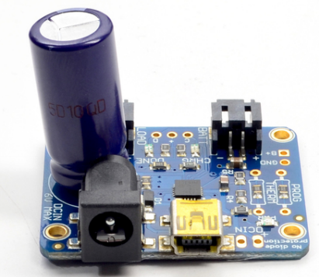

Single-cell LiPo MPPT charger

1. Features

* Input Supply Voltage Regulation Loop for Peak Power Tracking in (MPPT) Solar Applications
* Wide Input Voltage Range: 4.95V to 32V (40V Abs Max)
* Programmable Charge Rate Up to 2A
* User Selectable Termination: C/10 or On-Board Termination Timer
* Resistor Programmable Float Voltage Up to 14.4V Accommodates Li-Ion/Polymer, LiFePO4, SLA Chemistries
* No VIN Blocking Diode Required for Battery Voltages ≤ 4.2V
* 1MHz Fixed Frequency
* 0.5% Float Voltage Reference Accuracy
* 5% Charge Current Accuracy
* 2.5% C/10 Detection Accuracy
* Binary-Coded Open-Collector Status Pins
* 3mm × 3mm DFN12 or MSOP-12 Packages

1. Description

* The LT®3652 is a complete monolithic step-down battery charger that operates over a 4.95V to 32V input voltage range.
* The LT3652 provides a constant-current/ constant-voltage charge characteristic, with maximum charge current externally programmable up to 2A.
* The charger employs a 3.3V fl oat voltage feedback reference, so any desired battery fl oat voltage up to 14.4V can be programmed with a resistor divider.
* The LT3652 employs an input voltage regulation loop, which reduces charge current if the input voltage falls below a programmed level, set with a resistor divider.
* When the LT3652 is powered by a solar panel, the input regulation loop is used to maintain the panel at peak output power.
* The LT3652 can be confi gured to terminate charging when charge current falls below 1/10 of the programmed maximum (C/10).
* Once charging is terminated, the LT3652 enters a low-current (85μA) standby mode.
* An auto-recharge feature starts a new charging cycle if the battery voltage falls 2.5% below the programmed float voltage.
* An auto-recharge feature starts a new charging cycle if the battery voltage falls 2.5% below the programmed fl oat voltage.
* The LT3652 also contains a programmable safety timer, used to terminate charging after a desired time is reached.
* This allows top-off charging at currents less than C/10

1. Absolute maximum ratings

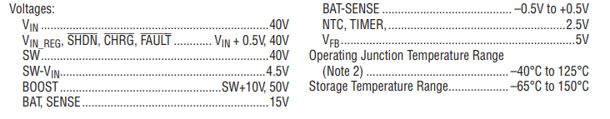

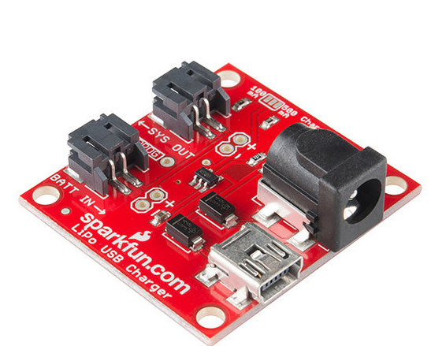

Differences

|  |  |  |  |
| --- | --- | --- | --- |
|  | Solar Charger Shield V2.2 | USB, DC & Solar Lipoly Charger | Single-cell LiPo MPPT charger |
| Output Disconnect | X |  |  |
| Short circuit protection | X | x |  |
| 3W Output Power when connecting battery | X |  | x |
| Continuous Charge Current Up to 500mA -900mA | X | X (when soldering extra resistor) | x |
| Battery status indication ( Red : Charging , Green: Charged ) | X | x |  |
| Micro-USB Connector | X | x | x |
| Load sharing |  | x |  |
| Temperature monitoring |  | x | x |
| Posibillity to ad external LEDs |  | x |  |
| Lithium-Polymer batteries | x | x | X |
| Lithium-Ion batteries | x | x | x |

Datasheets

<https://cdn-learn.adafruit.com/downloads/pdf/usb-dc-and-solar-lipoly-charger.pdf>

<https://static.chipdip.ru/lib/164/DOC001164903.pdf>

<http://cdn.sparkfun.com/datasheets/Prototyping/LT3652.pdf>

<https://www.distrelec.be/Web/Downloads/_t/ds/Adafruit_390_eng_tds.pdf?pid=30091214>